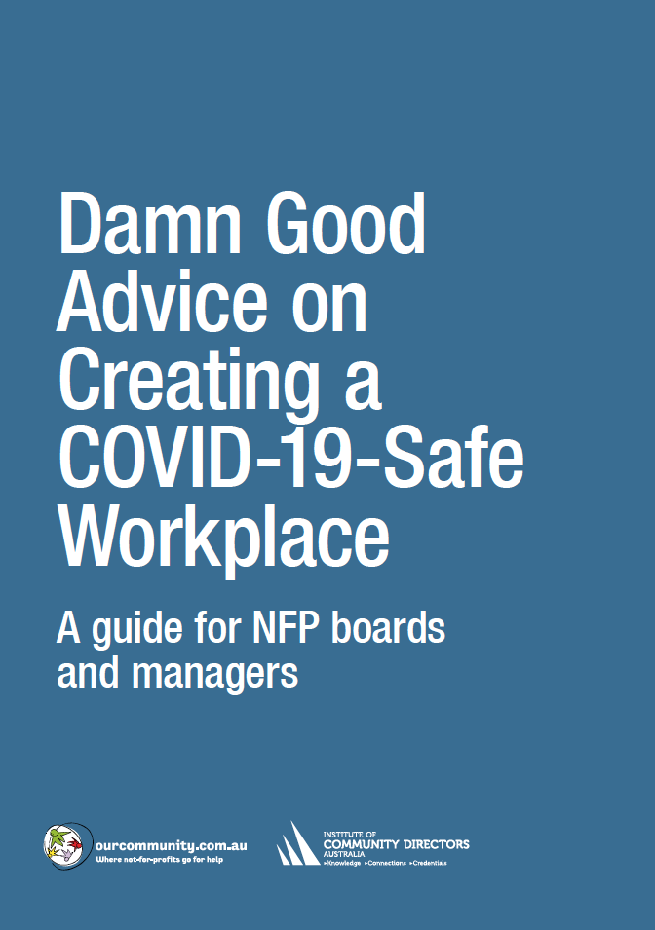

 | Building modifications checklist
 | Best practice | Responsible officer | Deadline | Satisfactory
General
 | Automatic doors installed or doors kept open | BH | 20 June | ✓
 | Signage installed throughout the building advising on maximum number of persons per room, taking into account physical distancing requirements | KE | 20 June | ✓
 | Furniture removed to enforce social distancing and discourage socialising
Reception
Signage | Notice of maximum building occupancy posted
 | Health precaution notices posted
Tracking | Receptionist monitoring maximum building occupancy
 | Receptionist keeping register of visitors (including contact details)
 | Receptionist keeping schedule of who to notify in case of incident
PPE | Hand sanitiser station (with notice requesting visitors use it)
Masks available (with notice requesting visitors use them) –
especially important for organisations working with vulnerable populations
Physical distancing | Separate in and out traffic streams
 | Chairs 1.5 metres apart
Hand transmission | Automatic doors installed or doors kept open
 | No magazines
Cleaning | Surfaces cleaned regularly (frequently touched surfaces such as door handles, handrails, lift buttons, photocopier, benchtops etc). For more on cleaning, see page 00.
Meeting rooms
Signage | Notices of maximum room occupancy posted
 | Incident procedures notice posted
PPE | Hand sanitiser station (with notice requesting employees use it)
 | Masks available (with notice requesting employees use them)
Hand transmission | Non-contact light activation installed
 | Automatic doors installed or doors kept open
Cleaning | Surfaces cleaned regularly
Co-working areas
Signage | Notices of maximum room occupancy posted
 | Health precaution notices posted
 | Incident procedures notice posted
PPE | Hand sanitiser station (with notice requesting employees use it)
 | Masks and disposable gloves available (with notice requesting employees use them)
Physical distancing | Notices of one-way traffic arrangements posted
 | Desks positioned 1.5 metres apart
 | Screen dividers installed between workstations
 | Physical distancing indicators at joint use facilities (printer, watercooler etc)
 | Excess furniture removed from break-out areas
Hand transmission | Automatic doors installed or doors kept open
Cleaning | Surfaces cleaned regularly
Lifts
Physical distancing | Notice of maximum capacity posted, taking into account physical distancing; users 1.5 metres apart
Cleaning | Surfaces cleaned regularly
Bathrooms
Signage | Notice of maximum room occupancy posted
 | Health precaution notices posted
 | Incident procedures notice posted
PPE | Hand sanitiser station (with notice requesting visitors use it)
Physical distancing | Some urinals closed, if necessary, to ensure 1.5 metre distancing
Hand transmission | Touch-free taps installed
 | Automatic doors installed or doors kept open
Cleaning | Surfaces cleaned regularly
Kitchen
Signage | Notice of maximum room occupancy posted
 | Health precaution notices posted
 | Incident procedures notice posted
PPE | Hand sanitiser station (with notice requesting visitors use it)
 | Disposable gloves provided
Physical distancing | Chairs and stools removed, if necessary
 | Physical distancing indicators posted at joint-use facilities
Hand transmission | Touch-free taps installed
 | Automatic doors installed or doors kept open
 | Tea towels removed and replaced with paper towels
 | Coffee machine, urn and kettle removed
Cleaning | Surfaces cleaned frequently (benchtops, refrigerator etc)
Isolation room
 | Uninhabited room designated for people needing to be temporarily quarantined

