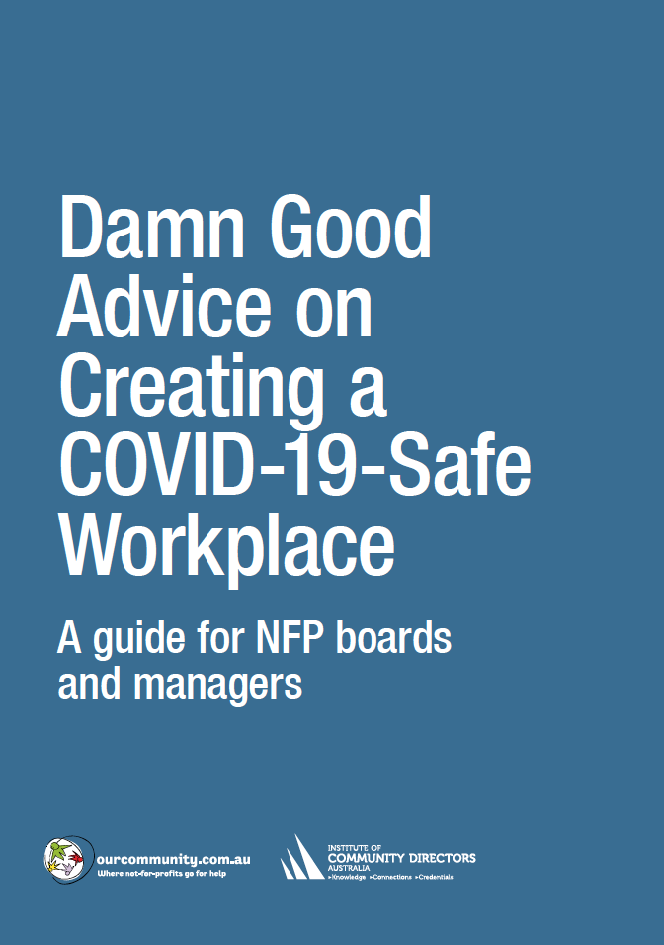

 | Dealing with the public – checklist
 | Best practice | Responsible officer | Deadline | Satisfactory
Supplies |  | HR | 20 June | ✓
 | Ensure sufficient supplies and materials, including tissues and hand sanitiser, are available for all customers/visitors. Have surgical masks available to provide to anyone who develops respiratory symptoms. | BH | 20 June | ✓
Cash handling
 | If possible, accept only cashless transactions.
 | If cash is accepted, issue cashiers with disposable gloves.
 | Put up signs asking customers not to touch objects unless they are going to buy them.
Communication
Assign responsibility for
- mounting posters at the entrance displaying health information (see www.health.gov.au/resources/collections/coronavirus-covid-19-campaign-resources#posters)
- mounting a poster in the public space outlining your Incident Procedures (see page 00)
- publishing health information online via your customer-facing channels (e.g. website, social media). Make clear to customers and clients that anyone with even a mild cough or low-grade fever (37.3 C or more) needs to stay at home. They should also stay home if they have had to take simple medications such as Paracetamol, ibuprofen or aspirin, which may mask symptoms of infection.
 | If you work by appointment, advise customers, visitors and clients in advance that if they have any symptoms, or feel unwell, they should not attend.
Information
You may – but you don’t have to – ask visitors and customers to provide contact details: mobile telephone number, email, and address where they are staying. State that their details will be shared with local public health authorities if any staff member, visitor or customer becomes ill with a suspected infectious disease.
Alternatively, you may ask visitors and customers to show that they have installed the COVIDSafe app on their mobile phone (www.health.gov.au/resources/apps-and-tools/covidsafe-app).
If you record contact details, retain them for at least three months to help health authorities trace people who may have been exposed to COVID-19.
Store personal information securely, and observe privacy requirements (see page 00).
Physical precautions | You may – but you certainly don’t have to – require customers and visitors to undergo a non-intrusive temperature check. If that’s necessary, you shouldn’t be opening your premises at all unless it’s absolutely unavoidable.  You may also require customers and visitors to wear masks, and you must require that they observe appropriate social distancing.
 | Nominate a person on the premises to be responsible for requiring customers and visitors to keep the required distance apart in accordance with the applicable government requirements.
Space customer or visitors according to social distancing rules.
Set building limits on this basis. Monitor customer numbers and make additional arrangements if you look like going over those numbers. If necessary, ask people to queue outside, preferably under cover. Adjust projections and planning to cope with anticipated numbers.
 | Open windows and doors whenever possible to make sure the building is well ventilated.
Incident procedures
If anyone starts to feel unwell, follow your Incident Procedures (see page 00).
If you are informed that someone in the building has been isolated as a suspected COVID-19 case, let all customers whose details are on record know this. They should be advised to monitor themselves for symptoms for 14 days and take their temperature twice a day. If they develop even a mild cough or low-grade fever (i.e. a temperature of 37.3 C or more) they should stay at home, self-isolate, and telephone their healthcare provider or the local public health department.

