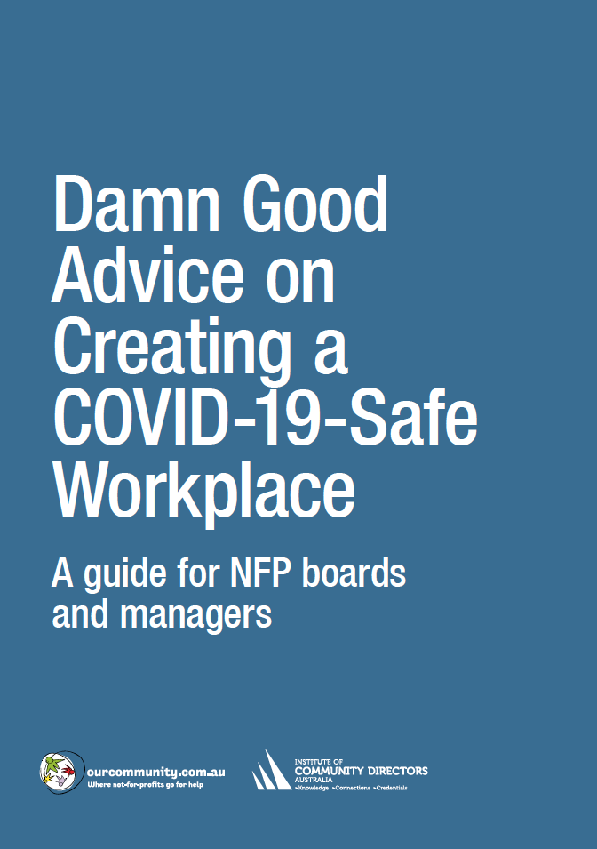

Incident Procedures | Incident procedures checklist
 | Best practice | Responsible officer | Deadline | Satisfactory
Building management
 | Designate a room or area where someone who is feeling unwell or has symptoms can be safely isolated until they are moved to a medical facility. | BH | 20 June | ✓
HR
 | Direct workers to stay home if they are sick. If they are displaying symptoms of COVID-19, ask them to call the national coronavirus helpline (1800 020 080).
 | Your organisation’s Epidemic & Pandemic Policy (see page 00) should ensure that leave procedures provide no incentive for anyone to come to work sick. Notify all staff of these arrangements.
Communication
Assign responsibility for
- mounting posters displaying information on the symptoms of COVID-19 and the procedures to be observed should anybody feel them coming on. (see www.health.gov.au/resources/collections/coronavirus-covid-19-campaign-resources#posters)
- publishing such information on the organisation’s intranet or via email. Make clear to staff that anyone with even a mild cough or low-grade fever (37.3 C or more) needs to stay at home. Staff should also stay home (or work from home) if they have had to take simple medications such as Paracetamol, ibuprofen or aspirin, which may mask symptoms of infection.
- communicating with employees individually (e.g. by email) on incident procedures
Information
 | Establish procedures enabling the organisation to identify every person who has entered each section of the premises on every day. Alternatively, ensure that every person on the premises has the CovidSafe app installed on their phone (https://www.health.gov.au/resources/apps-and-tools/covidsafe-app).
 | Identify the nearest COVID-19 testing centre and the nearest emergency medical facility equipped to deal with suspected cases. Mount the contact details for these in the isolation room.
Activation
In the event that an employee
- displays symptoms of COVID-19, or
- notifies you that they are experiencing those symptoms, or
- notifies you that they have become aware that they have been in contact with a person who has the virus
then activate the incident procedures below.
Incident procedures: immediate
 | Issue the person concerned with a mask. Wear one yourself. Escort the person to the isolation room. Arrange for their transport to the nearest testing or treatment facility.
 | Call the COVID-19 hotline for your state or territory and follow official advice.
 | Inform everybody who works in the area surrounding the person concerned that an incident has occurred – maintaining, as far as possible, confidentiality about the identity of the person concerned – and ask them to wash their hands. Attempting to maintain confidentiality may seem silly, considering how much information you will unavoidably have to give out: “The person who tested positive sat in this room, worked with this team and touched these doorhandles and that keyboard. On a completely unconnected topic, Jenny is now taking 14 days of leave.” Some discretion is recommended, nonetheless, both for legal reasons and out of concern for the privacy of the person concerned.
 | Arrange for the cleaning of all surfaces that the person concerned may possibly have come into contact with.
 | Recommend to staff who have been working with the person concerned that they get themselves tested. Pay for their tests if necessary.
 | Recommend to all other staff that they monitor their health (even more) carefully.
 | Make any necessary arrangements for staff to resume working from home, just in case.
 | Issue masks to every person who has been working in proximity to the person concerned.
Incident procedures: positive test | If the relevant authorities inform you that the person concerned has tested positive (or that any other person who has contracted the virus has had contact with your organisation) then:  - Decide whether the situation requires that the premises are shut down  - in part or as a whole for cleaning  - until procedures or fittings can be changed  - until all affected workers have been tested.  - Inform the staff of the circumstances  - Ask all affected staff to take a coronavirus test  - Ask all affected staff to leave the workplace and self-isolate themselves in their homes (or elsewhere, if necessary) until the results of their test are received or they are advised by the Department of Health Contact Tracing Unit that it is safe to resume normal activities.  - Inform staff that the Department of Health Contact Tracing Unit will contact anyone identified as having been in close contact, and that employees must follow its directions. For more information, see www.health.gov.au/sites/default/files/documents/2020/03/coronavirus-covid-19-information-for-close-contacts-of-a-confirmed-case_2.pdf  .  No staff member who has tested positive can return to work until they can demonstrate later that they have been medically cleared in line with Department of Health guidelines. (Public health officials will advise affected employees directly in relation to their self-isolation and medical clearance requirements.)  Employees who have not been in close contact with the affected person are not required to self-isolate.  It’s up to you to define what the ‘affected work area’ and the ‘affected employees’ consist of. This might be one office, a team area, an entire floor, an entire building, or an entire campus, depending on the interactions of the individuals. Take a precautionary approach, and close as much of the workplace as is reasonable to support employees’ peace of mind. For further advice, contact the National Coronavirus Helpline on 1800 020 080.
Inform all recent visitors to the facility that
- there has been a positive test
- they should consider getting themselves tested
- the Department of Health Contact Tracing Unit will contact anyone identified as having been in close contact.
Cleaning
Immediately arrange for the work area to be thoroughly cleaned and disinfected in line with specific cleaning advice for workplaces (for example, see www.health.gov.au/sites/default/files/documents/2020/03/environmental-cleaning-and-disinfection-principles-for-covid-19.pdf). Undertake this cleaning before advising employees that it’s safe to return to the workplace.
Employees should be contacted during the period of shutdown and advised of the steps being taken to clean the work environment.
When the workplace has been cleaned, employees should be advised that they can return to the workplace unless they are sick or are required to continue to self-isolate.

