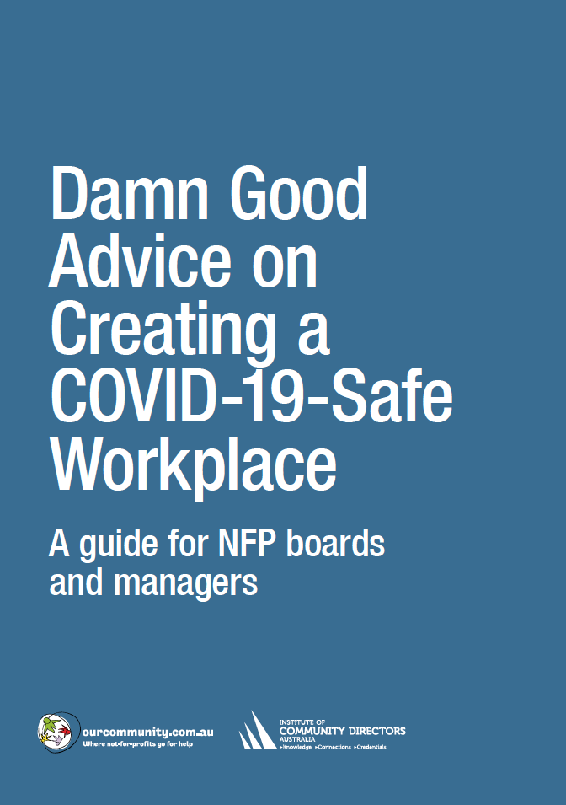

 | Meetings and events checklist
 | Best practice | Responsible officer | Deadline | Satisfactory
Supplies
 | Ensure sufficient supplies and materials, including tissues and hand sanitiser, are available for all participants. Have surgical masks available to provide to anyone who develops respiratory symptoms. | BH | 20 June | ✓
Communication
Assign responsibility for
- mounting posters displaying health information (see www.health.gov.au/resources/collections/coronavirus-covid-19-campaign-resources#posters)
- distributing health information to participants in advance. Make clear to participants that anyone with even a mild cough or low-grade fever (37.3 C or more) needs to stay at home. They should also stay home if they have had to take simple medications such as Paracetamol, ibuprofen or aspirin, which may mask symptoms of infection.
Information
Make sure that all organisers, participants, caterers and visitors at the event provide contact details: mobile telephone number, email, and address where they are staying. State that their details will be shared with local public health authorities if any participant becomes ill with a suspected infectious disease.
Alternatively, ask attendees to show that they have installed the COVIDSafe app on their mobile phone (www.health.gov.au/resources/apps-and-tools/covidsafe-app).
If they won’t agree to either of these contact tracing systems, advise them that they can’t attend the event or meeting. If necessary, refund their money.
Retain the names and contact details of all participants for at least three months to help health authorities trace people who may have been exposed to COVID-19 if one or more participants becomes ill shortly after the event.
Store personal information securely, and observe privacy requirements (see page 00).
 | During the meeting or event, provide information or a briefing, preferably both orally and in writing, on COVID-19 and the measures that organisers have taken to make the event safe for participants.
 | Draw up an incident reporting plan, including the provision of an isolation room. Inform attendees of its location.
Seating
Space participants according to social distancing rules, and set attendance limits on this basis. Install signs in each meeting room giving the maximum capacity of each room.
Adjust projections and planning to cope with reduced numbers.
 | Open windows and doors whenever possible to make sure the venue is well ventilated.
Incident Procedure
If anyone starts to feel unwell, follow your organisation’s Incident Procedures (see page 00).
If you are informed that someone who attended the meeting or event was later isolated as a suspected COVID-19 case, let all participants know this. They should be advised to monitor themselves for symptoms for 14 days and take their temperature twice a day. If they develop even a mild cough or low-grade fever (a temperature of 37.3 C or more) they should stay at home, self-isolate, and telephone their healthcare provider or the local public health department, giving details of their symptoms and recent travel.

