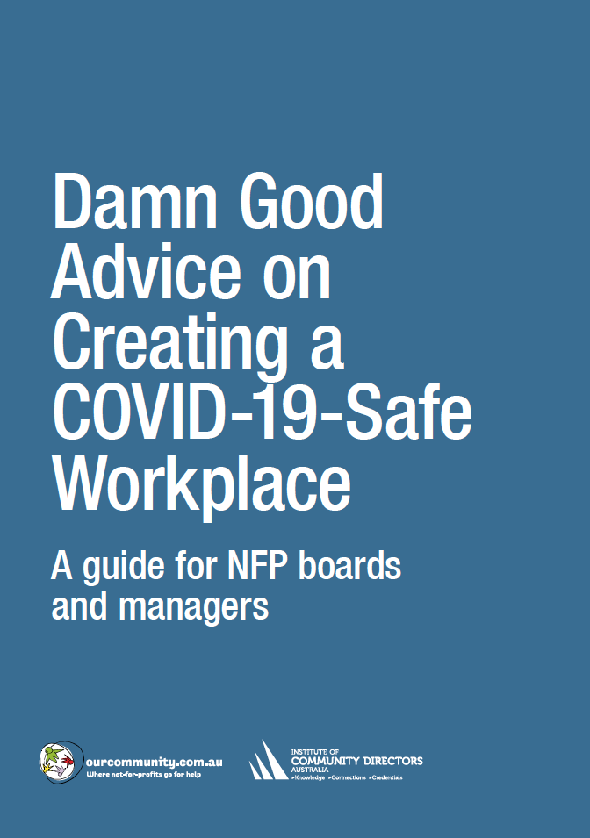

 | Policies and practices checklist
 | Best practice | Responsible officer | Deadline | Satisfactory
Policies
 | Design and adopt an Epidemic & Pandemic Policy. A template for such a policy is available from the ICDA Policy Bank: https://communitydirectors.com.au/policies/epidemic-pandemic-policy. | BH | 20 June | ✓
 | Design and adopt a Returning to the Workplace Policy. A template for such a policy is available on page 00. | KR | 20 June | ✓
Communication
Assign responsibility for
- mounting posters displaying health information (see www.health.gov.au/resources/collections/coronavirus-covid-19-campaign-resources#posters)
- publishing health information on the organisation’s intranet or via email. Make clear to staff that anyone with even a mild cough or low-grade fever (37.3 C or more) needs to stay at home. Staff should also stay home (or work from home) if they have had to take simple medications such as Paracetamol, ibuprofen or aspirin, which may mask symptoms of infection.
HR
 | Consult and negotiate with staff on work practices (see page 00), and modify agreements as necessary. Ensure that agreements contain provisions requiring employees and volunteers to observe health requirements, with provisions for discipline for breach.
Information
Collect contact information from visitors, clients, customers, contractors etc to facilitate contact tracing. See the template on page 00.
Alternatively, you can ask visitors, clients, customers, contractors etc to show that they have installed the COVIDSafe app on their mobile phone (www.health.gov.au/resources/apps-and-tools/covidsafe-app).
 | Develop policies and practices governing contact information consistent with privacy legislation and your organisation’s Privacy Policy (e.g. disposal schedules, use restrictions). A Privacy Policy template is available from the ICDA Policy Bank: https://communitydirectors.com.au/policies/privacy-policy.
 | Designate an employee to keep a record of which staff attend each area of the premises on each day, to allow contact tracing. Note: Staff cannot be required to use the COVIDSafe app, but they can be encouraged to do so.
Special circumstances
 | Organisations that undertake work with vulnerable client populations, work that entails physical contact with others, or outdoor work will need to develop specific hygiene and physical distancing procedures to suit their circumstances, and modify policies, procedures and documentation accordingly.

